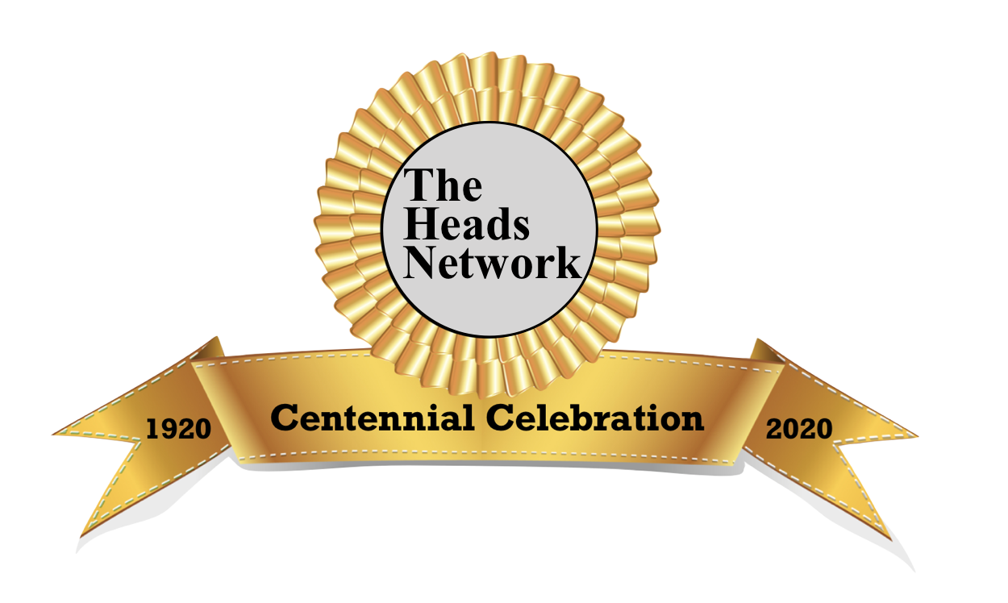
Speaker Agenda:
2020 Centennial Celebration Conference

100 Years of Women in Leadership: Celebrating our Past; Creating our Future

Sunday, February 23
9:00-12:00 Noon Board of Trustees Meeting
3:00 PM New Member/ New Head Reception
4:00-5:30 PM Opening Session:
Panel: Past, Present, Future…Women in Leadership
        - Donna Orem, Facilitator
        - Theo Coonrod, Retired HOS St. Mary’s School, NC
        - Katherine Dinh, HOS Marin Country Day, Ex-NAIS Board Chair
        - Lila Lohr, 9th Interim HOS at U. Prep. in Seattle, WA
        - Deborah Richman, Retired HOS Turning Point School, CA

Tributes

6:00 PM Reception
7:00 PM Seated Dinner

Monday, February 24
9:00-10:00 AM Keynote: Katty Kay
Journalist, Author and Broadcaster
BBC News Reporter based in D.C., co-author of
The Confidence Code

10-10:30AM Break: Meet and Greet Katty Kay

10:45-12:00 PM Jada Monica Drew
CEO of Social Design, Leadership Coach

12:15-1:15 PM Lunch and Celebration

1:15-2PM Samantha Ege
Music, Teacher at UWCSEA,
PhD Candidate at York University, UK

2:15-3:30 PM Jennifer Pharr Davis
Founder of Blue Ridge Hiking Co.

3:45-5:15PM Women In Leadership Seminar: Continuing the Journey

3:30-5:30 PM Optional Sponsor Sessions

6:00 PM Reception
7:00 PM Dinner

Tuesday, February 25
8:45-9:00 AM Annual Business Meeting

9:00-10:15 AM Dr. Beverly Daniel Tatum
President, Spelman College

10:30-11:45 AM The Most Rev. Dr. Katherine Jefferts Schori,
First Female Presiding Anglican Archbishop

11:45 AM Adjournment

